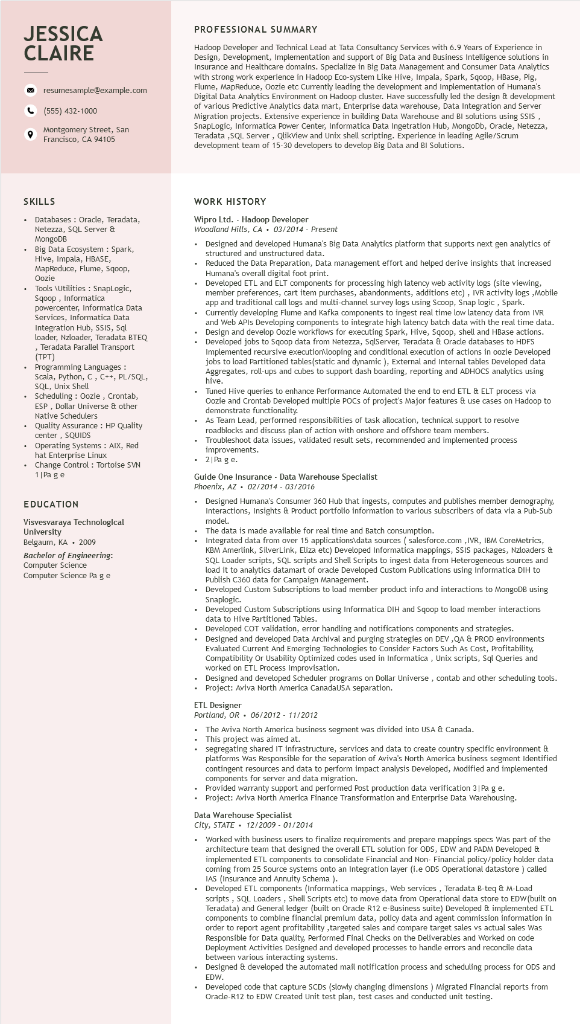
JESSICA CLAIRE
9
resumesample@example.com
(555) 432-1000
Montgomery Street, San Francisco, CA 94105
PROFESSIONAL SUMMARY
Hadoop Developer and Technical Lead at Tata Consultancy Services with 6.9 Years of Experience in Design, Development, Implementation and support of Big Data and Business Intelligence solutions in Insurance and Healthcare domains. Specialize in Big Data Management and Consumer Data Analytics with strong work experience in Hadoop Eco-system Like Hive, Impala, Spark, Sqoop, HBase, Pig, Flume, MapReduce, Oozie etc Currently leading the development and Implementation of Humana's Digital Data Analytics Environment on Hadoop cluster. Have successfully led the design & development of various Predictive Analytics data mart, Enterprise data warehouse, Data Integration and Server Migration projects. Extensive experience in building Data Warehouse and BI solutions using SSIS, SnapLogic, Informatica Power Center, Informatica Data Ingetration Hub, MongoDb, Oracle, Netezza, Teradata,SQL Server, QlikView and Unix shell scripting. Experience in leading Agile/Scrum development team of 15-30 developers to develop Big Data and BI Solutions.
SKILLS
• Databases: Oracle, Teradata, Netezza, SQL Server & MongoDB
• Big Data Ecosystem: Spark,
Hive, Impala, HBASE,
MapReduce, Flume, Sqoop, Oozie
Tools \Utilities: SnapLogic, Sqoop, Informatica
powercenter, Informatica Data
Services, Informatica Data
Integration Hub, SSIS, Sql
loader, Nzloader, Teradata BTEQ Teradata Parallel Transport (TPT)
Programming Languages:
Scala, Python, C, C++, PL/SQL, SQL, Unix Shell
• Scheduling: Oozie, Crontab, ESP, Dollar Universe & other Native Schedulers
Quality Assurance: HP Quality center, SQUIDS
Operating Systems: AIX, Red hat Enterprise Linux
Change Control: Tortoise SVN 1 | Pa ge
EDUCATION
Visvesvaraya Technological University
Belgaum, KA 2009
Bachelor of Engineering: Computer Science
Computer Science Pa ge
WORK HISTORY
Wipro Ltd. - Hadoop Developer
Woodland Hills, CA
.
•
•
03/2014 - Present
Designed and developed Humana's Big Data Analytics platform that supports next gen analytics of structured and unstructured data.
Reduced the Data Preparation, Data management effort and helped derive insights that increased Humana's overall digital foot print.
y logs,Mobile
• Developed ETL and ELT components for processing high latency web activity logs (site viewing, member preferences, cart item purchases, abandonments, additions etc), IVR activity and traditional call logs and multi-channel survey logs using Scoop, Snap logic, Spark. app and Lloar and mult Currently developing Flume and Kafka components to to ingest real time low latency data from IVR and Web APIs Developing components to integrate high latency batch data with the real time data. Design and develop Oozie workflows for executing Spark, Hive, Sqoop, shell and HBase actions. Developed jobs to Sqoop data from Netezza, SqlServer, Teradata & Oracle databases to HDFS Implemented recursive execution\looping and conditional execution of actions in oozie Developed jobs to load Partitioned tables (static and dynamic ), External and Internal tables Developed data Aggregates, roll-ups and cubes to support dash boarding, reporting and ADHOCS analytics using
•
hive.
Tuned Hive queries to enhance Performance Automated the end to end ETL & ELT process via Oozie and Crontab Developed multiple POCs of project's Major features & use cases on Hadoop to demonstrate functionality.
As Team Lead, performed responsibilities of task allocation, technical support to resolve roadblocks and discuss plan of action with onshore and offshore team members. Troubleshoot data issues, validated result sets, recommended and implemented process improvements.
2|Pa ge.
Guide One Insurance - Data Warehouse Specialist
Phoenix, AZ. 02/2014 - 03/2016
Designed Humana's Consumer 360 Hub that ingests, computes and publishes member demography, Interactions, Insights & Product portfolio information to various subscribers of data via a Pub-Sub model.
The data is made available for real time and Batch consumption.
Integrated data from over 15 applications\data sources (salesforce.com,IVR, IBM CoreMetrics, KBM Amerlink, SilverLink, Eliza etc) Developed Informatica mappings, SSIS packages, Nzloaders & SQL Loader scripts, SQL scripts and Shell Scripts to ingest data from Heterogeneous sources and load it to analytics datamart of oracle Developed Custom Publications using Informatica DIH to Publish C360 data for Campaign Management.
Developed Custom Subscriptions to load member product info and interactions to MongoDB using Snaplogic.
Developed Custom Subscriptions using Informatica DIH and Sqoop to load member interactions data to Hive Partitioned Tables.
Developed COT validation, error handling and notifications components and strategies. Designed and developed Data Archival and purging strategies on DEV,QA & PROD environments Evaluated Current And Emerging Technologies to Consider Factors Such As Cost, Profitability, Compatibility Or Usability Optimized codes used in Informatica, Unix scripts, Sql Queries and worked on ETL Process Improvisation.
• Designed and developed Scheduler programs on Dollar Universe, contab and other scheduling tools.
• Project: Aviva North America CanadaUSA separation.
ETL Designer
Portland, OR. 06/2012 - 11/2012
The Aviva North America business segment was divided into USA & Canada. This project was aimed at.
segregating shared IT infrastructure, services and data to create country specific environment & platforms Was Responsible for the separation of Aviva's North America business segment Identified contingent resources and data to perform impact analysis Developed, Modified and implemented components for server and data migration.
Provided warranty support and performed Post production data verification 3 | Pa g e.
• Project: Aviva North America Finance Transformation and Enterprise Data Warehousing.
Data Warehouse Specialist
City, STATE
•
.
12/2009 - 01/2014
Worked with business users to finalize requirements and prepare mappings specs Was part of the architecture team that designed the overall ETL solution for ODS, EDW and PADM Developed & implemented ETL components to consolidate Financial and Non- Financial policy/policy holder data coming from 25 Source systems onto an Integration layer (i.e ODS Operational datastore) called IAS (Insurance and Annuity Schema).
Developed ETL components (Informatica mappings, Web services, Teradata B-teq & M-Load scripts, SQL Loaders, Shell Scripts etc) to move data from Operational data store to EDW(built on Teradata) and General ledger (built on Oracle R12 e-Business suite) Developed & implemented ETL components to combine financial premium data, policy data and agent commission information in order to report agent profitability, targeted sales and compare target sales vs actual sales Was Responsible for Data quality, Performed Final Checks on the Deliverables and Worked on code Deployment Activities Designed and developed processes to handle errors and reconcile data between various interacting systems.
Designed & developed the automated mail notification process and scheduling process for ODS and EDW.
Developed code that capture SCDs (slowly changing dimensions) Migrated Financial reports from Oracle-R12 to EDW Created Unit test plan, test cases and conducted unit testing.

